Knowledge Lab User Guide

Tong Zhu, Kevin Chang, Nichola Shackleton and Barry Milne

COMPASS Research Centre

The University of Auckland

March 2017

**Contents**

[1 Introduction 3](#_Toc397952821)

[2 Getting Started 5](#_Toc397952822)

[2.1 Menus 5](#_Toc397952823)

[3 Tree navigation 6](#_Toc397952824)

[3.1 Saving Tables 7](#_Toc397952825)

[3.2 Saving graphs 7](#_Toc397952826)

[4 Table Builder 8](#_Toc397952827)

[5 Running Scenarios 9](#_Toc397952828)

[5.1 Scenario Builder 9](#_Toc397952829)

[5.2 Scenarios on the whole population (i.e. no subgroups) 10](#_Toc397952830)

[5.3 Scenarios for subgroups 11](#_Toc397952831)

[5.4 Viewing the results of scenarios 12](#_Toc397952832)

[5.5 Interpreting results 12](#_Toc397952833)

[6 Saving and Reloading Work 13](#_Toc397952834)

[7 Known Limitation 13](#_Toc397952835)

[8 Help 13](#_Toc397952836)

[9 References 14](#_Toc397952837)

# Introduction

This is a guide for the ‘Knowledge Laboratory of the early life-course’ (Knowledge Lab) micro-simulation model using Shiny R package and R programming language (Shiny App). ‘Beta’ versions of the application and model were produced, and underwent testing from September 2016 – February 2017. The next deployment version is now ready.

A Knowledge Laboratory of the early life-course’ (Knowledge Lab)

Knowledge Lab uses microsimulation to build an accurate model of early life-course development (birth to age 21) in New Zealand. Microsimulation relies on data from the real world to create an artificial one that mimics the original but upon which virtual experiments can be carried out (Gilbert and Troitzsch 2005). Each individual unit has a set of associated attributes as a starting point, and a set of rules is then applied in a stochastic manner to the units to simulate changes in state or behaviour over time. This dynamic micro-simulation model (Rutter, et al. 2011; Spielauer 2007) essentially generates a set of diverse synthetic histories for a population of individuals. Modifications of influential factors can then be carried out to test hypothetical ‘what if’ scenarios on key down-stream outcomes of policy interest.

Knowledge Lab uses a discrete-time cohort microsimulation in that the simulated units (children) are aged year-by-year from a fixed starting point (birth). No new individuals enter as the simulation progresses through time and individual attributes are updated in annual steps.

The conceptual framework for Knowledge Lab was developed in collaboration with seven government agencies: Ministry of Health, Ministry of Education, Ministry of Justice, Ministry of Social Development, the Children’s Commission, and the Social Policy Evaluation and Research Unit (SuPERU). We chose to focus on three outcome areas – obesity, education and mental health – and conceptual models were then developed based on literature search on the etiology of each outcome (see below).

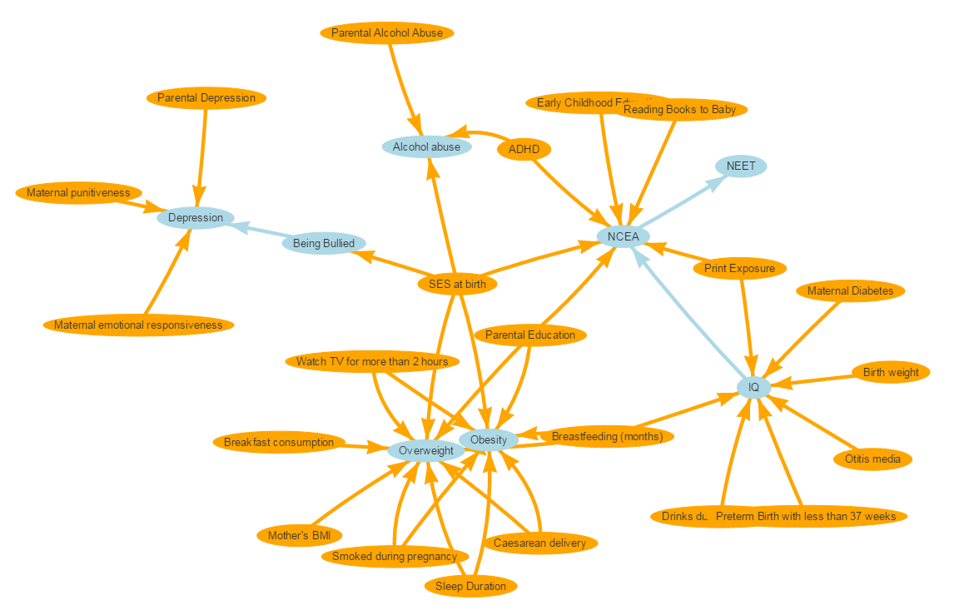

The two main components required for the Knowledge Lab model to function are:

(i) A sample of units (children) to use as a starting population. A sample of n = 10000 ‘synthetic’ children was created by analysing new-borns from the 2006 Census (Statistics New Zealand, 2006). The sample is thus representative of New Zealand children but does not contain data from any actual individual (Milne, Lay-Yee, McLay, Pearson, von Randow & Davis, 2015).

(ii) A series of rules that stochastically determine the characteristics units acquire as they age. These were derived by meta-analyses of longitudinal studies. A literature search was carried out to identify relevant systematic reviews/meta-analyses related to the conceptual framework shown above. Relevant studies were identified and assessed for study quality. A list of all studies identified, along with their quality assessment is shown in Appendix B, and a list of meta-analyses with their estimates and reference is given in Appendix C.

Shiny App

Shiny App is an open source R package that provides an interactive web application framework for R language, in which the discrete-time micro-simulation models are written. Thus, the Shiny App can be shared as a web page, which allows the user to run across a number of different platforms, and does not require any specialist software to be installed.

This user’s guide will describe how to use the Shiny App software to run Knowledge Lab models.

# Getting Started

Open a web browser (Google Chrome preferred) and go to

<https://compassnz.shinyapps.io/knowlabshiny/>

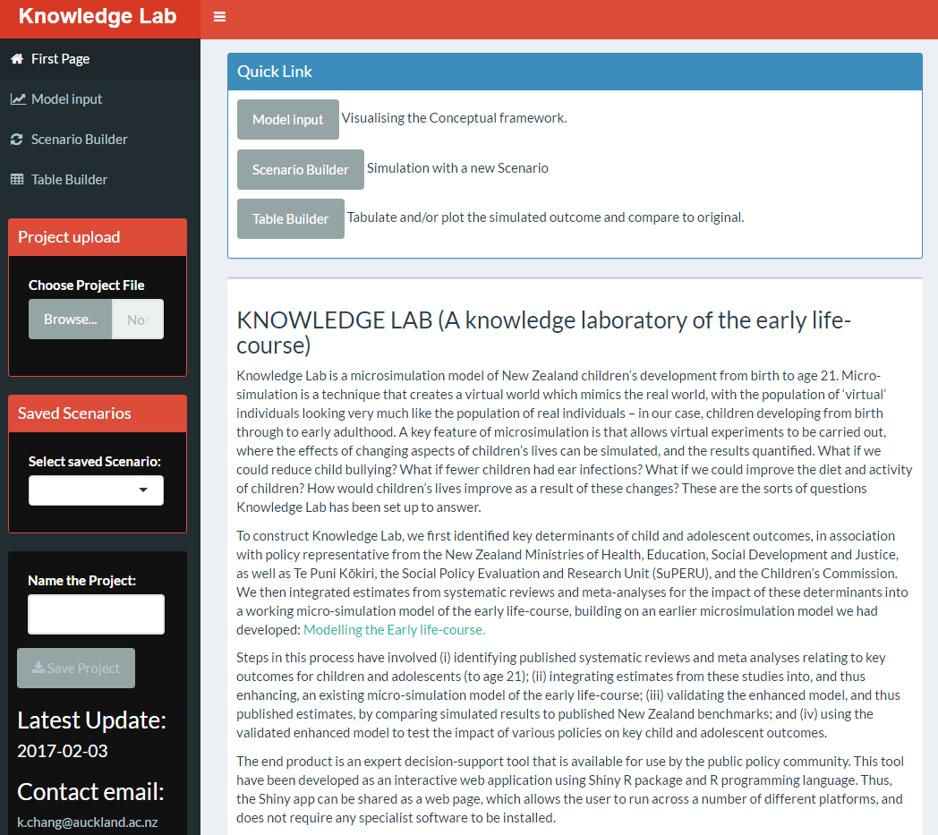

This will open Knowledge Lab models as a Shiny App in the form of an interactive web page.

Knowledge Lab uses a two panel layout with *Navigation Panel* on the left (in black background) and *Output Panel* on the right. Navigation Panel can be hidden by clicking S:\Research Groups\COMPASS\Projects\MBIE-KnowledgeLab\Users Guide\kl_user_guide_figs\kl_user_guide_first_page_02.PNG in the header.

# Navigation Panel

The navigation panel includes:

* First Page: outlines a brief introduction to the Knowledge Lab model. It is the default page when Knowledge Lab is opened.
* Model Input: visualises the conceptual framework. It displays all variables (bubbles) used in the simulation model as well as their paths (arrows).
* Scenario Builder: runs scenarios by adjusting distributions of variables.
* Table Builder: builds and displays tables and charts of variable distributions, both before and after scenarios have been run. Scenario outcomes and ‘base’ outcomes can be compared.
* Project Upload: loads saved projects, including scenario settings and results.
* Scenarios Run: lists all scenarios run and allows a scenario to be selected for comparison with base outcomes.
* Save Project: saves project and its scenario settings and results.

# First Page

This gives a brief introduction to the Knowledge Lab model. It also provides quick links to Model Input, Scenario Builder and Table Builder (shown in figure below).

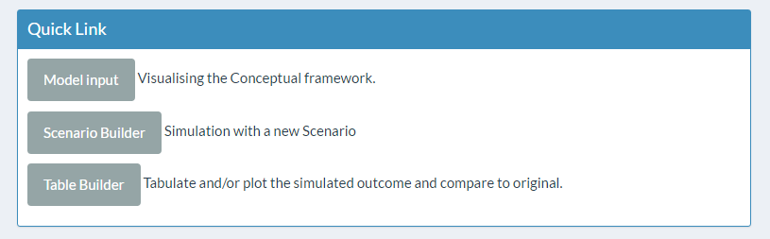

# Model Input

It visualises the conceptual framework of the Knowledge Lab model. It displays all variables (bubbles) used in the simulation model as well as their paths (arrows).

Hover over a bubble to see the levels for that variable (variables are listed and described in Appendix A, see figure below for an example with “Depression”). Single click on a bubble to highlight all paths for models involving that variable. Note that a single click will also autocomplete STEP 2 “Select Variable to Examine” in Scenario Builder and STEP 2 “Choose variable” in Table Builder.

Outcome variables are highlighted in light blue and predictor variables are highlighted in yellow. Variables which are not directly related to the selected variable - but are related to a variable in the path model for the selected variable - are highlighted in light grey (see figure below for an example with “Depression” – “NCEA” is not directly related to depression, but is related to the variable “SES at birth”, which is on the path for Depression).

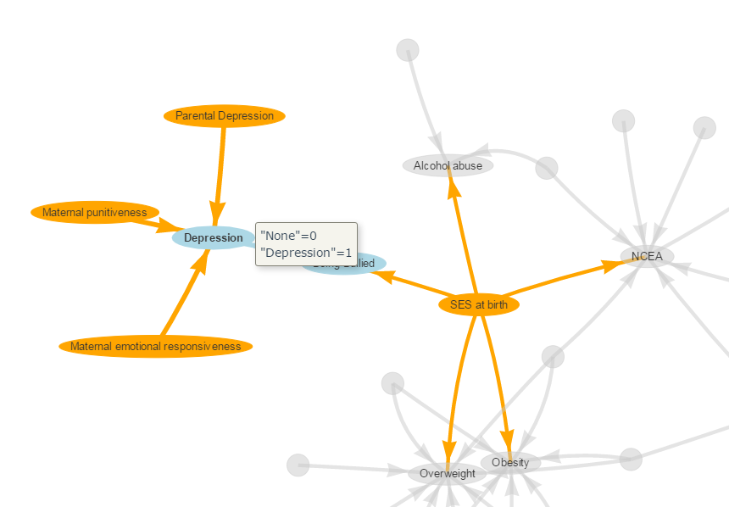

Hover over an arrow to see the coefficient and citation for that path (see figure below for an example with “Maternal emotional responsiveness” – “Depression”). Single click on an arrow to open the citation for that coefficient.

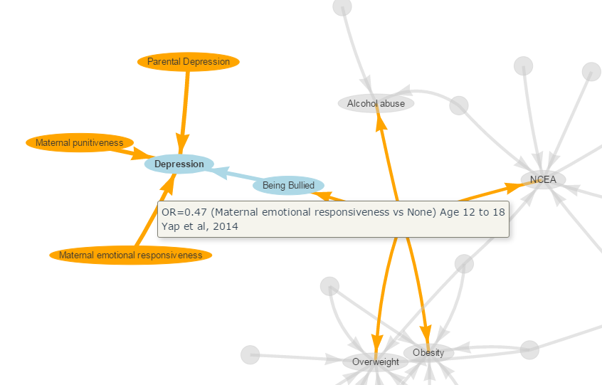

# Scenario Builder

The main use of Knowledge Lab is to test the effects of ‘what if’ scenarios on the underlying population. The Scenario Builder interface allows you to make changes to the distributions of variables at certain points in the simulation. The flow-on effects of these changes on the outcome measures of interest can then be examined in tables and graphs (in Table Builder).

To start, click on ‘Scenario Builder’ from the navigation panel and the interface will be displayed in the main working area on the right. It consists of two panels: “Variable” and “Setting the Scenario”. “Setting the Scenario” consists of two sub-panels: “Variable Adjustment” and “Base value for the Variable”.

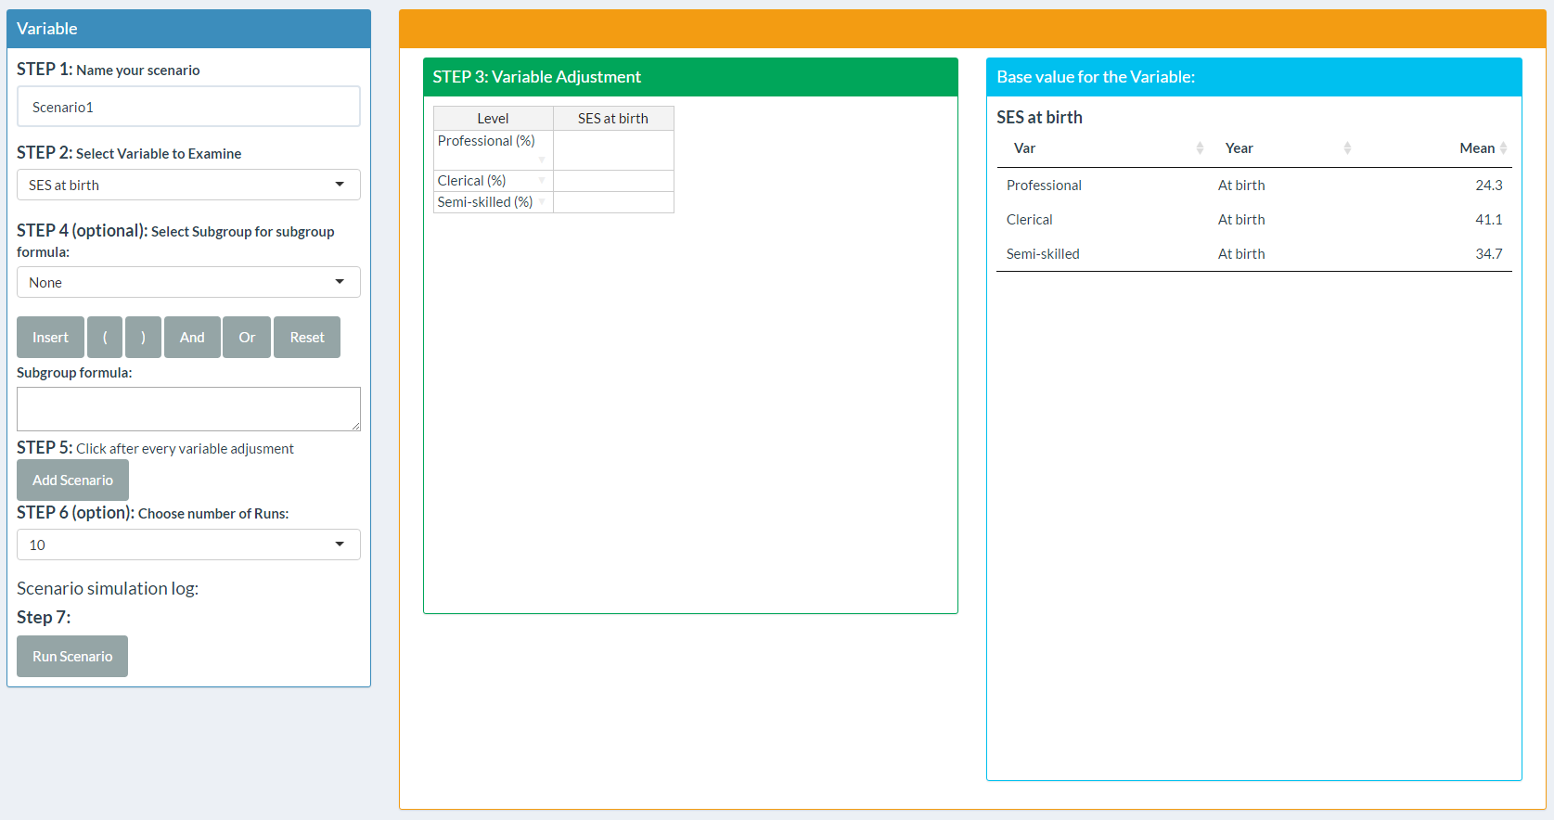

## Run simulation

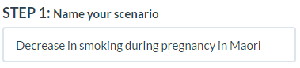

1. Type in the box to give your scenario a name – it can help to remind you what the scenario was testing

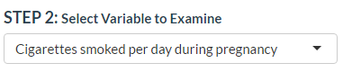

2. Choose the variable you want to change. Baseline distribution of this variable will appear in the “Base value for the Variable” panel.

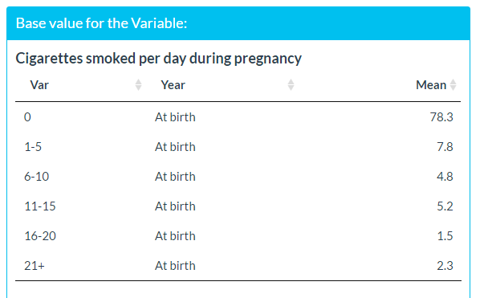

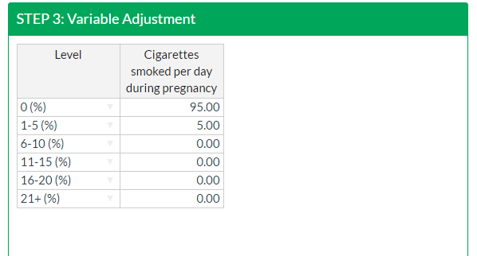

3. Change the distribution of this variable to that desired. Make sure that the distribution is bounded to 100% in total.

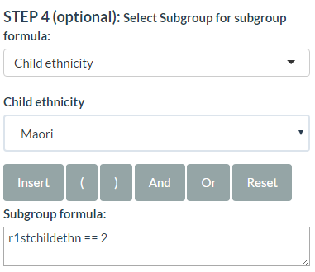

4. Choose the variable you want to subgroup by (default is set at “None” for the whole population). Then choose the subgroup of interest.

Different variables will have different options. Categorical variables will list the categories. Select the category you want (e.g. “Child ethnicity” and “Maori”and then **CLICK “Insert”** (IMPORTANT!)**.**

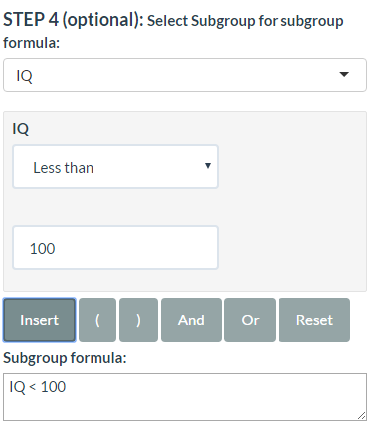

Continuous variables will give interval options such as ‘equals’ or ‘less than’ etc, to which you add values in the adjacent box. E.g., if you want IQ < 100 as your subgroup, select IQ as the variable, select ‘less than’ as the option, type ‘100’ and then **CLICK “Insert”** (IMPORTANT!)**.**

Alternatively, you can click in the formula box and edit manually (it helps to know R code if you want to edit manually).

You may combine as many subgroup expressions as you need by using the ‘And’ and ‘Or’ buttons (written as ‘&’ and ‘|’).

As an example, say you want to select ethnicity = Māori AND single parent family at birth = TRUE. Specify the first argument, then click ‘And’, then specify the second argument. Alternatively, in the formula box type:   
*r1stchildethnLvl2==1 & z1single0Lvl1==1*

Click ‘Reset’ to refresh all settings for subgroup.

Be careful with the formula logic – selecting a subgroup variable and then changing your mind and selecting another will append rather than overwrite, and this may produce an error. If it does, click ‘Reset’ and try again.

With a subgroup scenario, any changes you make to variables will ONLY apply to the subgroup you specify.

5. Click “Add Scenario” to update base simulation percentages for the current variable.

A summary of your simulation will be shown in the “Scenario simulation log”.

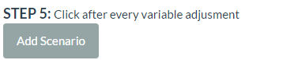

6. Choose from the dropdown menu the number of runs for the simulation. The default is set as the maximum run allowed at 10.

More runs will give you tighter confidence intervals, but the simulation will take longer to run.

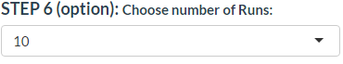

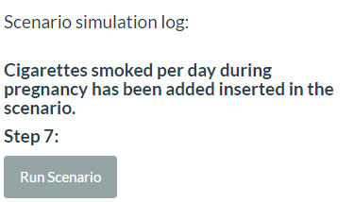

7. Run your scenario by clicking “Run Scenario”. A warning message with simulation log will pop up and click “Yes, Run Scenario” to proceed with the simulation. Click “No” to stop.

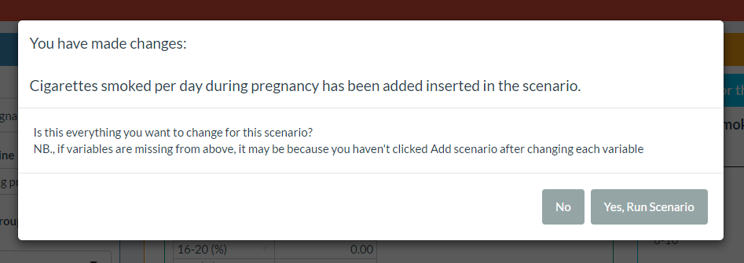

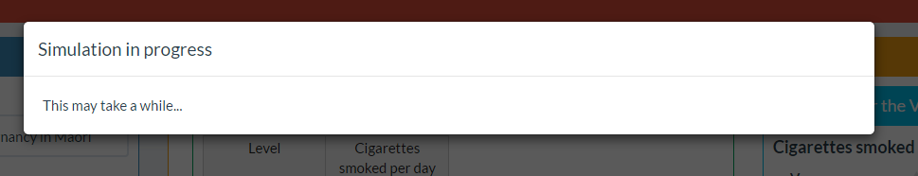

8. Once “Yes, Run Scenario” has been clicked, the interface will be locked with the “Simulation in progress” message until simulation is completed.

## Viewing the results of scenarios

After a scenario has finished running, tables and charts for scenarios can be built using Table Builder, as described in Section 7.

## Interpreting results

The effects of a scenario are best interpreted by comparing the results of a ‘base’ simulation (i.e., where no factors in the children’s lives have been altered) to the results of the ‘scenario’ simulation. For example, the figure below shows the effect of improving early childhood education (ECE) participation rate (from 95.9% to 100%) on NCEA pass rates. The improvement on ECE participation is marginal at 4.1%, as a result we confine our attention to only those 4.1% population (who changed from no participation to participation in ECE) and compare NCEA pass rates in “base” and “scenario” simulations. It is shown (in the figure below) that NCEA pass rate has improved, albeit without statistical significance (indicated by overlapping 95% confidence intervals).

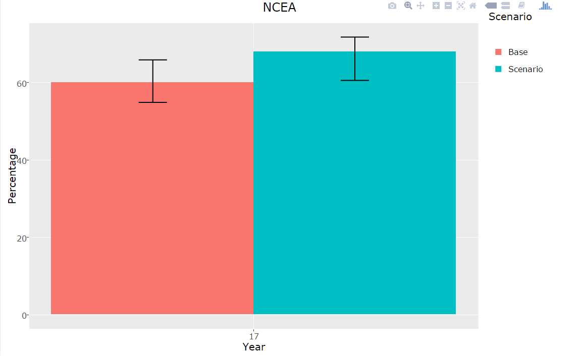

# Table Builder

The Table Builder allows summary measures – percentages, means and quantiles – to be displayed for variables of interest. Summary measures can also be grouped by a second variable. The Table Builder also allows the impacts of scenarios to be visually displayed by comparing results of a scenario against the ‘base’ simulation (i.e., where no factors in the children’s lives have been altered). An example of this is shown below.

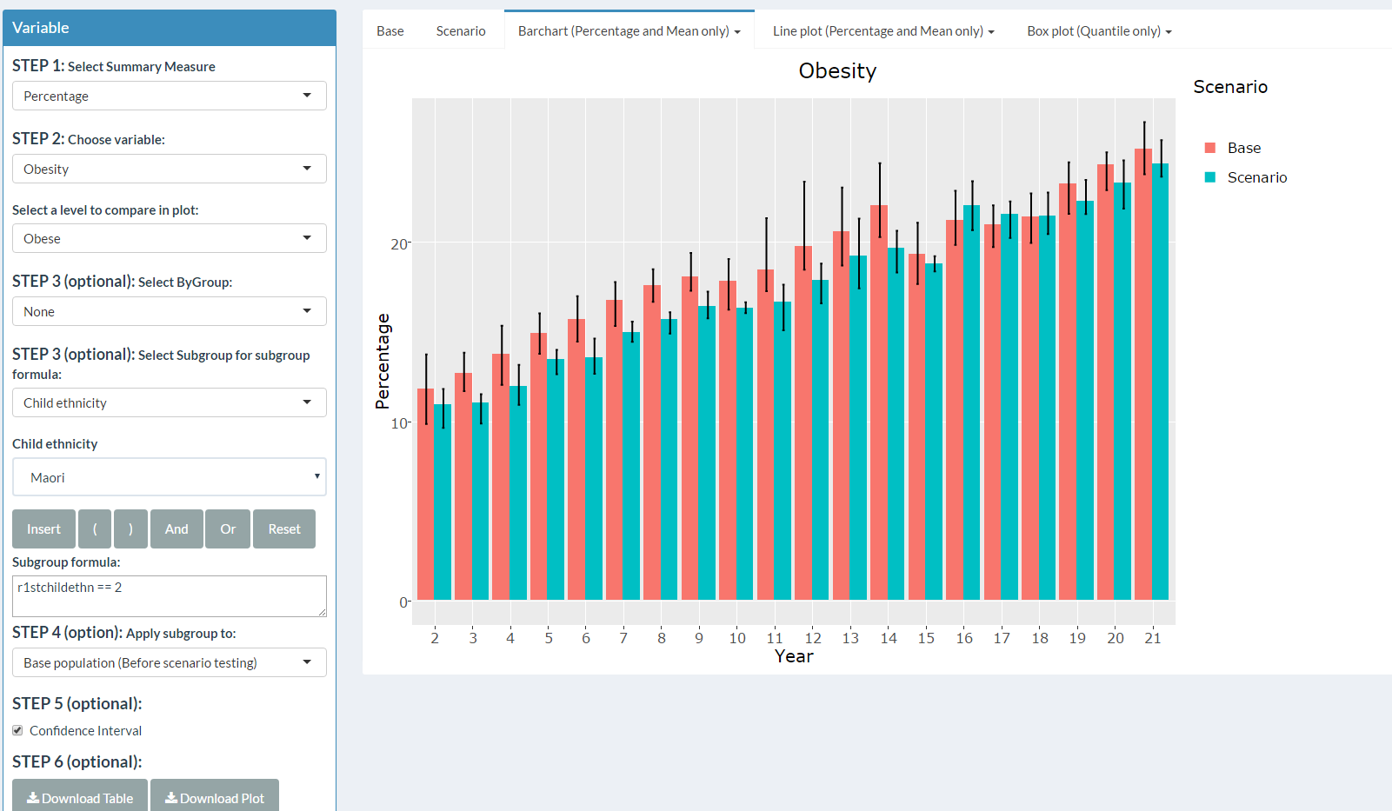

The Table Builder interface is displayed in the main working area. Use the following six steps as required.

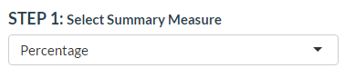

1. Select either percentages, means or quantiles. Only categorical variables will be displayed as percentages and only continuous variables will be displayed as means and quantiles.

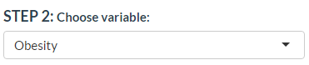

2. Select the variable you want to summarise.  
  
Select level you want to display in plot (e.g., in the example shown you can display percentages of those who are obese or of those who are not obese)

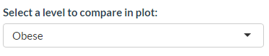

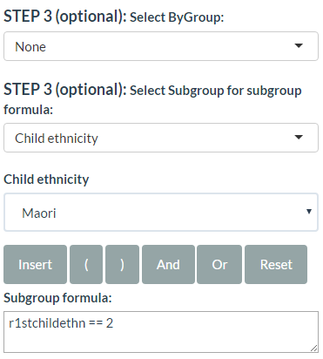

4. Choose Scenario Population if you want to apply the subgroup to the population as it is after applying the scenario (the default).

Choose Base Population if you want to apply the subgroup to the population as it was before applying the scenario.

Select this only if you want to see the effect of a scenario specifically for a group that you changed – i.e. if the subgrouping variable is the same as a scenario variable. For example, you may want to assess the effect of ECE attendance specifically for those who changed from non-attendance to attendance

3. Select a grouping variable (optional) if you want tables stratified by a second variable.

See Scenario Builder for detailed explanation of how to use the formula builder.

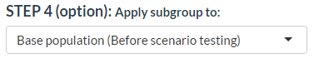

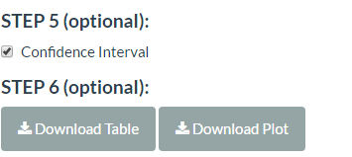

6. You can save tables in xls format by clicking “Download Table” and save plots in png format by clicking “Download Plot”.

5. Tick or untick to show or hide confidence intervals.

# Saving and Reloading Work

When you have run your scenarios and generated the tables you want to look at, you can save your work and come back to it later, without having to take the time to run those scenarios again. In the navigation panel type the project name in the “Name the Project” text box and click ‘Save Project’. The file saved is an R Data file format, and by default it saves to My Documents (the ‘Workspaces’ shortcut takes you here). You can navigate to the Desktop and save there for easier access.

Now you can close the program. When you open it again, click on the “Browse” under the “Choose Project File” box, and select the file that you saved. This may take a minute or so, but it is a lot faster than rerunning scenarios, and will bring back all of the tables and scenarios that you saved, and you can even go to Table Builder and access those scenarios to generate further tables.

# Known Limitation

Currently, the shiny application is hosted in shinyapps.io, which uses Amazon cloud computing services in Amazon’s AWS US-East region. Thus, we do not have ability to control and maintain the server management side of the application. One implication of this is that the application will time out after 1 hour of inactivity (and this cannot be changed). We strongly recommend saving your project frequently.

# Help

If you have any problems or there is something you don’t understand, please email: [b.milne@auckland.ac.nz](mailto:b.milne@auckland.ac.nz) (about the construction of the model and interpretation of results)

[k.change@auckland.ac.nz](mailto:k.change@auckland.ac.nz) (technical support)

# References

Gilbert, N. and Troitzsch, K. (2005) Simulation for the Social Scientist, Maidenhead: Open University Press.

Milne B, Lay-Yee R, McLay J, Pearson J, von Randow M, Davis P. Modelling the Early life-course (MELC): A microsimulation model of child development in New Zealand. [International Journal of Microsimulation](http://www.microsimulation.org/IJM/V8_2/3_Milne_Lay-Yee_McLay_Pearson_vRandow_Davis.pdf), 2015, 8 (2), 28-60.

Rutter, C.M. Zaslavsky, A.M. and Feuer, E.J. (2011), ‘Dynamic Microsimulation Models for Health Outcomes : A Review’, Medical Decision Making, 31: 10.

Statistics New Zealand. (2006) 2006 Census birth cohort SURF, <http://www.stats.govt.nz/tools_and_services/university-students/2006-census-birth-cohort.aspx>

Spielauer, M. (2007) ‘Dynamic microsimulation of health care demand, health care finance and the economic impact of health behaviours: survey and research’, International Journal of Microsimulation, 1(1): 35–53.

# Appendix A – Knowledge Laboratory Variables

|  |  |  |
| --- | --- | --- |
| **TIME INVARIANT** | | |
| **ses at birth** | based on occupation of father | professional/clerical/semi skilled |
| **child ethnicity** |  | nz european/maori/pacific/asian |
| **gender** |  | male/female |
| **maternal emotional responsiveness** | the extent to which the mother is attuned to the child’s needs and responds in a warm and loving manner. A high score implies high emotional responsiveness. Derived from the HOME inventory | Yes/No |
| **maternal punitiveness** | the extent to which the mother utilized a restrictive and punitive parenting style. A high score implies greater punitiveness. Derived from the HOME inventory | Yes/No |
| **ADHD** |  | Yes/No |
| **Breastfeeding** | in months | 0/1/2/3/4/5/6/7/8/9/10/11/12+ |
| **Breakfast consumption** |  | Yes/No |
| **Mother's BMI** |  | Normal/Underweight/Overweight/Obese |
| **Caesarean delivery** |  | Yes/No |
| **smoking during pregnancy** | cigarettes per day | 0/1-5/6-10/11-15/16-20/21+ |
| **Otitis media** |  | Yes/No |
| **Birthweight** | in kilograms | <2.5/2.5-2.999/3.0-3.499/3.500-3.999/4.0+ |
| **Maternal Diabetes** |  | Yes/No |
| **Print Exposure** |  | Yes/No |
| **drinks during pregnancy** | per week | 0/1/2/3/4/5/6/7/8+ |
| **Early Childhood Education** |  | Yes/No |
| **Parental Education** | Highest education level between parents | tertiary/secondary/none |
| **Reading Books to Baby** |  | Yes/No |
| **Watch TV for more than 2 hours** |  | Yes/No |
| **Preterm Birth with less than 37 weeks** |  | Yes/No |
|  |  |  |
| **TIME DYNAMIC, CATEGORICAL** | | |
| **Being bullied** |  | Yes/No |
| **Parental Alcohol Abuse** |  | Yes/No |
| **Parental Depression** |  | Yes/No |
| **Alcohol abuse** |  | Yes/No |
| **Depression** |  | Yes/No |
| **Overweight** |  | Yes/No |
| **Obesity** |  | Yes/No |
| **Sleep Duration** |  | Short/Normal/Long |
| **NCEA** |  | Attained/Failed/Dropout |
| **Not in employment, education, or training (NEET)** |  | Yes/No |
|  |  |  |
| **TIME DYNAMIC, COUNT/CONTINUOUS** | | |
| **IQ** |  |  |
|  |  |  |

# Appendix B – List of all meta-analysis studies identified, with their quality assessment

Add excel work book link here

# Appendix C – Summary of Meta-analysis estimates and citations for each model path

|  |  |  |  |
| --- | --- | --- | --- |
| Dependent Variable | Independent Variable | Summary | Reference Link |
| Alcohol abuse | SES at birth | OR = 1.54 (most deprived vs least deprived) Ministry of Health, 2015 | http://www.health.govt.nz/publication/annual-update-key-results-2014-15-new-zealand-health-survey |
| ADHD | OR = 1.74 (ADHD vs none) Lee et al, 2011 | https://www.ncbi.nlm.nih.gov/pubmed/21382538 |
| Parental alcohol abuse | OR = 1.47 (parental alcohol abuse vs none) [Age 12 to 21] Bergen et al, 2007 | https://www.ncbi.nlm.nih.gov/pubmed/17564500 |
| Being bullied | SES at birth | OR = 1.38 (most deprived vs middle level) Denny et al, 2014 | http://www.tandfonline.com/doi/abs/10.1080/15388220.2014.910470 |
| Depression | Being bullied | OR = 1.74 (being bullied vs not being bullied) [Age 10 to 21] Ttofi et al, 2011 | http://www.emeraldinsight.com/doi/full/10.1108/17596591111132873 |
| Maternal punitiveness | OR = 1.54 (maternal punitiveness vs none) Norman et al, 2012 | https://www.ncbi.nlm.nih.gov/pubmed/23209385 |
| Maternal emotional responsiveness | OR = 0.47 (maternal emotional responsiveness vs none) [Age 12 to 18] Yap et al, 2014 | http://www.sciencedirect.com/science/article/pii/S0165032713008057 |
| Parental depression | OR = 2.67 (parental depression vs none) [Age 4 to 21] Micco et al, 2009 | https://www.ncbi.nlm.nih.gov/pubmed/19709850 |
| NCEA | SES at birth | Coeff = -4.19 (most deprived vs least deprived) [School-aged children] Sirin 2005 | http://rer.sagepub.com/content/75/3/417.abstract |
| Highest education level between parents | Coeff = -4.65 (no formal qualification vs tertiary) Sirin 2005 | https://goo.gl/S0dgq5 |
| Print exposure | Coeff = 10.23 (print exposure vs none) [Age 21] Mol & Bus, 2011 | http://psycnet.apa.org/journals/bul/137/2/267 |
| Early childhood education | Coeff = 2.12 (early childhood education vs none) [Age 3 to 10+] Camilli et al, 2010 | http://eric.ed.gov/?id=EJ888457 |
| ADHD | Coeff = -11.06 (ADHD vs none) Frazier et al 2007 | http://ldx.sagepub.com/content/40/1/49.abstract |
| Reading books to baby | Coeff = 5.43 (reading books to baby vs none) Jeynes, 2012 | http://uex.sagepub.com/content/47/4/706.abstract |
| IQ | Coeff = 0.57 Strenze, 2007 | http://www.sciencedirect.com/science/article/pii/S0160289606001127 |

|  |  |  |  |
| --- | --- | --- | --- |
| Dependent Variable | Independent Variable | Summary | Reference Link |
| Not in employment, education, or training (NEET) | NCEA | OR = 2.58 (passed vs none) [Age 17-21] Pacheco and van der Westhuizen, 2016 | http://foundation.vodafone.co.nz/wp-content/uploads/2016/10/YNEET-REASEARCH.pdf |
| IQ | Gestational age (weeks) | Coeff = -11.94 (preterm birth vs none) [Age 3 to 16] Kerr-Wilson et al, 2013 | https://www.ncbi.nlm.nih.gov/pubmed/21393308 |
| Birth weight | Coeff = -4.98 (birthweight < 2500g vs >= 2500g) [Age 13 to 21] Kormos et al, 2014 | https://www.ncbi.nlm.nih.gov/pubmed/23896861 |
| Maternal diabetes | Coeff = -11.70 (maternal diabetes vs none) [Age 3 to 12] Robles et al, 2015 | https://www.ncbi.nlm.nih.gov/pubmed/26566144 |
| Otitis media | Coeff = -6.30 (otitis media vs none) [Age 1 to 5] Roberts et al, 2004 | https://www.ncbi.nlm.nih.gov/pubmed/14993583 |
| Print exposure | Coeff = 5.58 (print exposure vs none) [Age 6 to 21] Mol & Bus, 2011 | https://www.ncbi.nlm.nih.gov/pubmed/21219054 |
| Drinks per week during pregnancy | Coeff = -1.95 (drinks more than 4 times per weeks vs less than 5 times per weeks) [Age 0.5 to 14] Flak et al, 2013 | https://www.ncbi.nlm.nih.gov/pubmed/23905882 |
| Breastfeeding (months) | Coeff = 0.02 (breastfeeding 1 month vs none) Coeff = 1.68 (breastfeeding 2 month vs none) Coeff = 2.15 (breastfeeding 3-4 month vs none) Coeff = 2.78 (breastfeeding 5-6 month vs none) Coeff = 2.91 (breastfeeding 7 month or more vs none) [Age 0.5 to 15] Anderson et al, 1999 | http://ajcn.nutrition.org/content/70/4/525.full |
| Preterm birth | Coeff = -11.94 (preterm birth with less than 37 weeks vs more than 37 weeks) [Age 3 to 16] Kovachy et al, 2014 | http://onlinelibrary.wiley.com/doi/10.1111/dmcn.12652/abstract |

|  |  |  |  |
| --- | --- | --- | --- |
| Dependent Variable | Independent Variable | Summary | Reference Link |
| Obesity | TV hours | OR = 4.57 (yes vs no) Wu et al, 2015 | https://goo.gl/0XzuvU |
| Highest education level between parents | OR = 1.62 (no formal qualification vs tertiary) Wu et al, 2015 | https://goo.gl/cfLgEB |
| SES at birth | OR = 1.73 (most deprived vs least deprived) [Age 1 to 15] Wu et al, 2015 | https://goo.gl/rj1RNT |
| Breastfeeding (months) | OR = 0.78 (breastfed vs not breastfed) [Age 2 to 14] Yan et al, 2014 | http://bmcpublichealth.biomedcentral.com/articles/10.1186/1471-2458-14-1267 |
| Sleep duration | OR = 1.89 (not short sleep vs short sleep) [Age 0.5 to 18] Cappuccio et al, 2008 | https://www.google.co.nz/url?sa=t&rct=j&q=&esrc=s&source=web&cd=1&cad=rja&uact=8&ved=0ahUKEwj9u9et0enQAhWDJ8AKHTrnBGcQFggfMAA&url=https%3A%2F%2Fwww.ncbi.nlm.nih.gov%2Fpmc%2Farticles%2FPMC2398753%2F&usg=AFQjCNFRnfOG1AShq8RtydmK8u5w4lDkpw&sig2=T5jSR-tZOvkckVnjZhokxg |
| Caesarean delivery | OR = 1.37 (caesarean delivery vs vaginal) [Age 3 to 25] Li et al, 2013 | https://goo.gl/7e9iUL |
| Cigarettes smoked per day during pregnancy | OR = 1.52 (smoking in pregnancy vs none) Weng et al, 2012 | https://www.google.co.nz/url?sa=t&rct=j&q=&esrc=s&source=web&cd=1&cad=rja&uact=8&ved=0ahUKEwjGl7fn0enQAhUlJMAKHSvaC04QFggdMAA&url=https%3A%2F%2Fwww.ncbi.nlm.nih.gov%2Fpubmed%2F19400912&usg=AFQjCNGEb9zswPkoqPLAxgSLBnz6miB3fA&sig2=nWY4\_Zhxpvsvb5nrVBC2MA |

|  |  |  |  |
| --- | --- | --- | --- |
| Dependent Variable | Independent Variable | Summary | Reference Link |
| Overweight | SES at birth | OR = 1.58 (most deprived vs least deprived) [Age 1 to 15] Wu et al, 2015 | https://www.ncbi.nlm.nih.gov/pmc/articles/PMC4481703/ |
| Breastfeeding (months) | OR = 0.85 (breastfed vs not breastfed) [Age 2 to 14] Weng et al, 2012 | http://adc.bmj.com/content/97/12/1019.short |
| Sleep duration | OR = 0.43 (normal sleep vs short sleep) OR = 0.68 (long sleep vs short sleep) [Age 0.5 to 18] Fatima et al, 2015 | https://www.ncbi.nlm.nih.gov/pubmed/25589359 |
| Breakfast consumption | OR = 0.57 [Age 5 to 18] OR = 0.52 [Age 19 and above] (has breakfast vs no breakfast) Horikawa et al, 2011 | https://www.ncbi.nlm.nih.gov/pubmed/21925535 |
| Mother's BMI | OR = 0.46 (underweight vs normal) [Age 2 to 12] OR = 1.04 (overweight vs normal) [Age 2 to 3] OR = 1.40 (overweight vs normal) [Age 4 to 5] OR = 2.11 (overweight vs normal) [Age 6 to 9] OR = 1.37 (obese vs normal) [Age 2 to 3] OR = 1.69 (obese vs normal) [Age 4 to 5] OR = 2.91 (obese vs normal) [Age 6 to 9] Yu et al, 2013 | https://www.ncbi.nlm.nih.gov/pubmed/23613888 |
| Caesarean delivery | OR = 1.32 (caesarean delivery vs vaginal) [Age 3 to 25] Li et al, 2013 | https://www.ncbi.nlm.nih.gov/pubmed/23207407 |
| Cigarettes smoked per day during pregnancy | OR = 1.47 (smoking in pregnancy vs none) Weng et al, 2012 | https://www.ncbi.nlm.nih.gov/pubmed/23109090 |
| Highest education level between parents | OR = 1.16 (no formal qualification vs tertiary) Wu et al, 2015 | https://goo.gl/YNXpWS |
| TV hours | OR = 3.86 (yes vs no) Wu et al, 2015 | https://www.ncbi.nlm.nih.gov/pmc/articles/PMC3186735/ |